CIS 300
Web Design and Development

Project Assignment | Project Update #1

Name: ___Cecilia Idiaquez____
Student ID: _1214406193_____
Date: __June 28, 2026_________

Instructions: You should have one page (1 html file and 1 css file) of your site completed by the time you submit this. Use the following to have a written discussion about the current progress of your website. After answering the questions below, insert a screenshot of the index.html file's browser view that you have completed so far (remember, you should have one page’s browser view and a CSS file). Do NOT screenshot the HTML code, as we can’t run the code. Save the file to yourasurite – Project Assignment – Project Update 1.docx file and yourasurite – Project Assignment – Project Update 1.pdf file. Submit both files to Canvas.

- How do you feel your website is coming along? (5 points)

I feel my website is simple and I wish I knew how to make a website with more fun elements but for my first time doing a whole website its going ok. I just get a little worried I’m entering things wrong

- What issues have you encountered on your first few pages? (4 points) How did you fix those issues, if you did? (3 points) Are there any issues still unresolved? (3 points)

An issue i encountered was the color scheme I had chosen. As I was entering my background, text, and accent colors they all blended together to much to make out any of the different part of the wed page. Another issue i had was finding a picture that would work best for my header and on the actual wed page. For the color issue i did resolve it and chose different color that worked better and made the wed page look presentable as for the photos I had to choose multiple once and see which I like best. An issue i still have is sizing of different parts of the website like text and how big I want certain items.

- Tables are useful when you need to display data in an organized and structured format, such as schedules, pricing lists, or comparison charts. They help improve readability and allow users to quickly interpret information. Describe in which page you would like to use a table on your website (2 point) and what info will be included in that table (8 points). Please note: A table needs to have at least a header row + at least three data rows + at least three columns.

I’d like to have a table on my EDM page where i can do a simple break down of the different types of EDM there is. I’ll list about five genres or more in the first column. in the second column I’ll give a small explanation of each and on the last column ill list the festival that mainly play the genre of music. The header will read Quick EDM Guide.

- Where would you like to use a form on your website? (2 points) What will the form be used for? (2 points) Draw a simple sketch of how it will look (what fields will be included, any basic styling, etc.) and paste it below: (6 points) Please note: A form should have at least 4 fields

I’d like to have my form on the first page of my website, to collect Name, Email, Comments, and the question Have you been to a Music Festival?

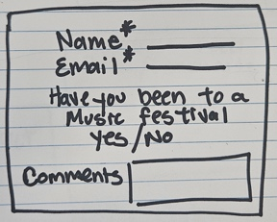

CIS 300
Web Design and Development

Project Assignment | Project Update #1

- List the live URL of your project website hosted on GitHub Pages. (15points)

https://cidiaque-idiaquez.github.io/Idiaque--Project/

- After doing several pages, has your sitemap changed? If so, revise your previous sitemap and insert it below: (10 points).

After doing several pages I did change the way my header area is as well as where I had my copyright and contact information, but the main content area stood the same.

- Insert the latest wireframe below: (10 points)

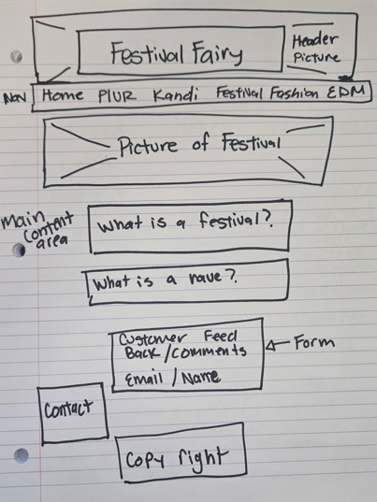

CIS 300
Web Design and Development

Project Assignment | Project Update #1
Web page browser view screenshot of Page #1 (15 points)
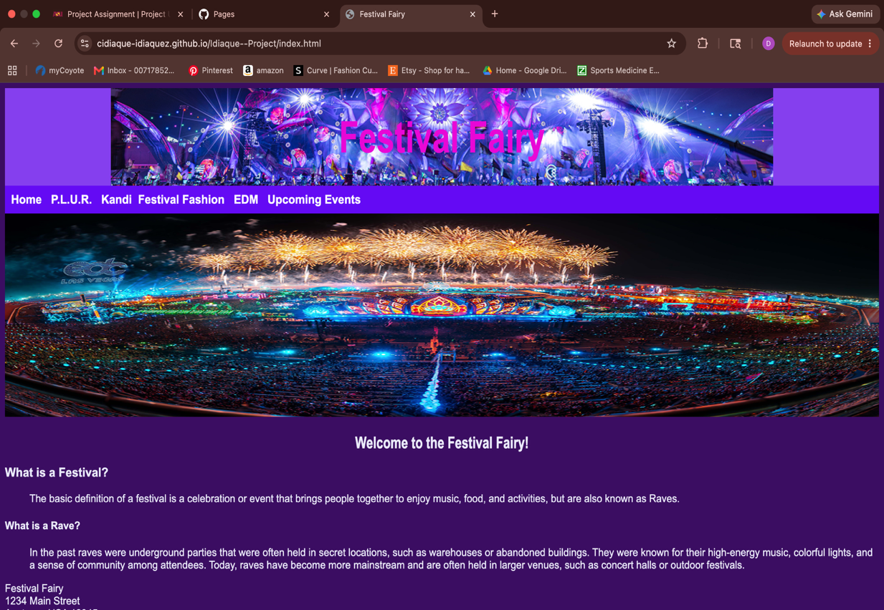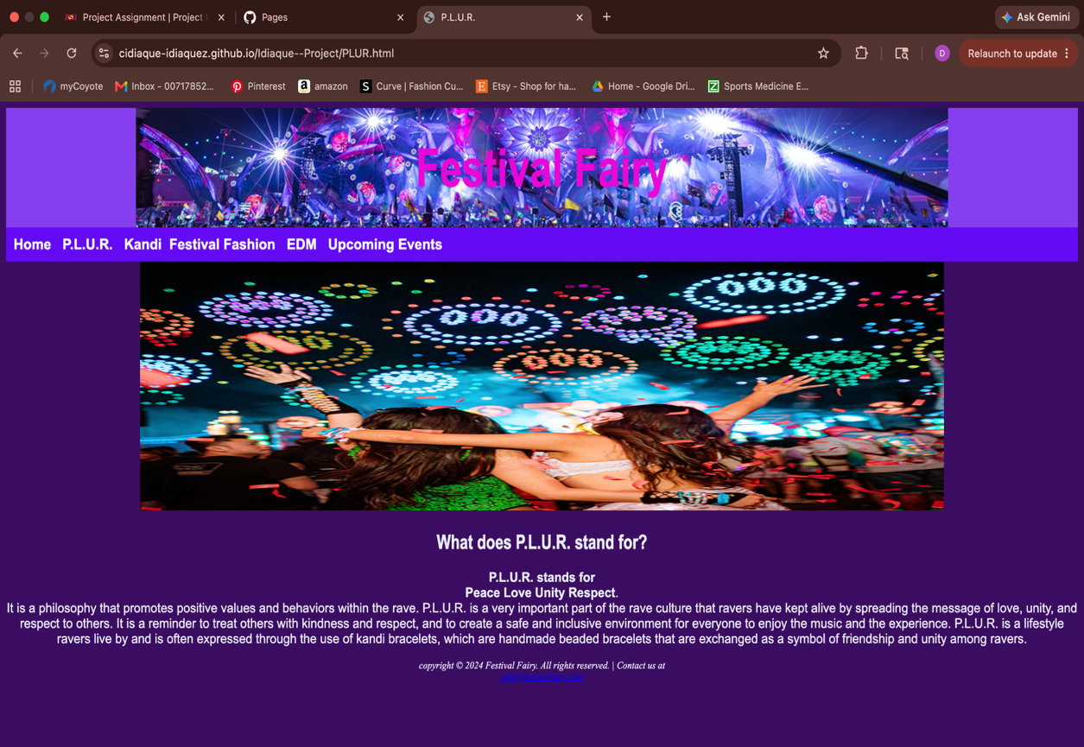

CIS 300
Web Design and Development

Project Assignment | Project Update #1
Screenshot of CSS file
Should include at least 5 selectors and 15 properties (15 points, 1 point for each)

